Design Report Components

(approved project-specific outline with lead instructor & client by April 7th)

# Letter of Transmittal (could be text of an email)

* Addressed to sponsor, interested parties
* Says “here’s an (interim, final) report on the XYZ project”
* Provide appropriate acknowledge for sponsor support

# Cover Page

Title, Authors, Contact Info, Logos

# Front Matter

## Table of Contents

Make it easy for people to find things

* For headings, look at the Report Body section below

## Executive Summary – ½ page

Too much time and effort are spent by those looking for a place to park in one or more garages in downtown Coeur d’ Alene. Commuters would benefit greatly from a system that indicates whether there are spaces available for parking within a parking garage. The Garage Sensor System (GSS) will allow people to find open parking spaces, and hopefully provide this information before they enter the garage. The means of indication will be via LEDs; a green light means there is an open stall, where a red means the stall is currently occupied by another  
vehicle. This is not the complete functionality of the system, but rather a level of abstraction for the consumer; the data that is measured/collected, will be distributed from device to device via a mesh network, then sent through a gateway where it will be received at The Den as a means of data collection for possible further research.

A short, powerful synopsis

* Intro sentence: what you are designing
* Needs -> Features of solution -> Benefits
* Pivotal technical and business merits
* Summary of quantitative test results

# Report Body

## Background – ½ page

* Describe sponsor motivation for the work
* Identify the need/opportunity associated with this project
* Summarize benefits to different stakeholders

## Problem Definition – 1 page

Park-IT-CdA is a parking garage monitoring system located in Coeur d’Alene, Idaho at the parking garage between 3rd and 4th Avenue and along Coeur d’Alene Avenue. It is capable of detecting when a car is parked in a stall and will relay this information to a server which will monitor the parking garage’s statistics such as: time from entering the garage to finding a stall, average time a stall is occupied, average number of stalls used.

The objective of this document is to state the requirements of the Garage Sensor System (GSS). The GSS is comprised of 5 Garage Sensor Units (GSU). The GSUs will decide among themselves which is to be the Garage Sensor Master (GSM).

The deliverables are to be the following:

* 5 GSU’s which includes the enclosure, computer hardware – sensors, LEDs, embedded system.
* 1 Gateway to be installed on the roof of the Innovation Den.
* Software to run the GSS – Arduino sketches, simulation.
* User manual on how to operate the GSUs and simulation
* The portfolio including all documentation of the requirements, design process, project learning, communications, design solution and references.
* Inventory specifications & constraints (preferably in table format w/units & target values)

## Project Plan – 1 page

## Team Members

Nikolai Tiong

Roles

* Team Leader
* Mesh network design
* Mesh network testing
* Documentation

Zane Goodrich

Roles

* Sensors for the GSUs
* Hardware design – sensors, power
* Hardware testing
* Documentation

Tyrel Parker

Roles

* Processing received data from GSS
* Simulation Software
* Hardware purchasing
* Documentation

Joel Berain

Joined Spring 2020

Roles

* Organizing the Wiki page
* Getting caught up on the project
* Documentation
* Encryption of messages
* Discuss intended and actual Schedule (reference Gantt charts in Appendix)

## Concepts Considered – 3+ pages

* Summarize seminal original ideas as well as those derived from other sources

(Don’t lead reader down dead ends, emphasize only feasible ideas that could work)

* Provide critical supporting data/measurements (with further details in Appendix)

## Concept Selection – 1 page

The Coronavirus and subsequent cancellation of in person classes along with the current situation has resulted in the project changing to the following:

* Use Zane’s driveway for the 2 GSU’s that he has
* Obtain larger antennas from John to attach them to
* The GSUs will then transmit over to Nikolai’s house where the GSM will reside
* Use the GSM to send to Tyrel’s house, possibly over the internet so that he can receive and process the data. Might need to use the ESP32 from RTOS in some manner.
* This way we still make use of the LoRa radios and the sensors, but over a much longer distance: Nikolai and Zane are approx. 1 mile apart while the garage was only 400 ft away from the Den.
* The battery is no longer a concern.

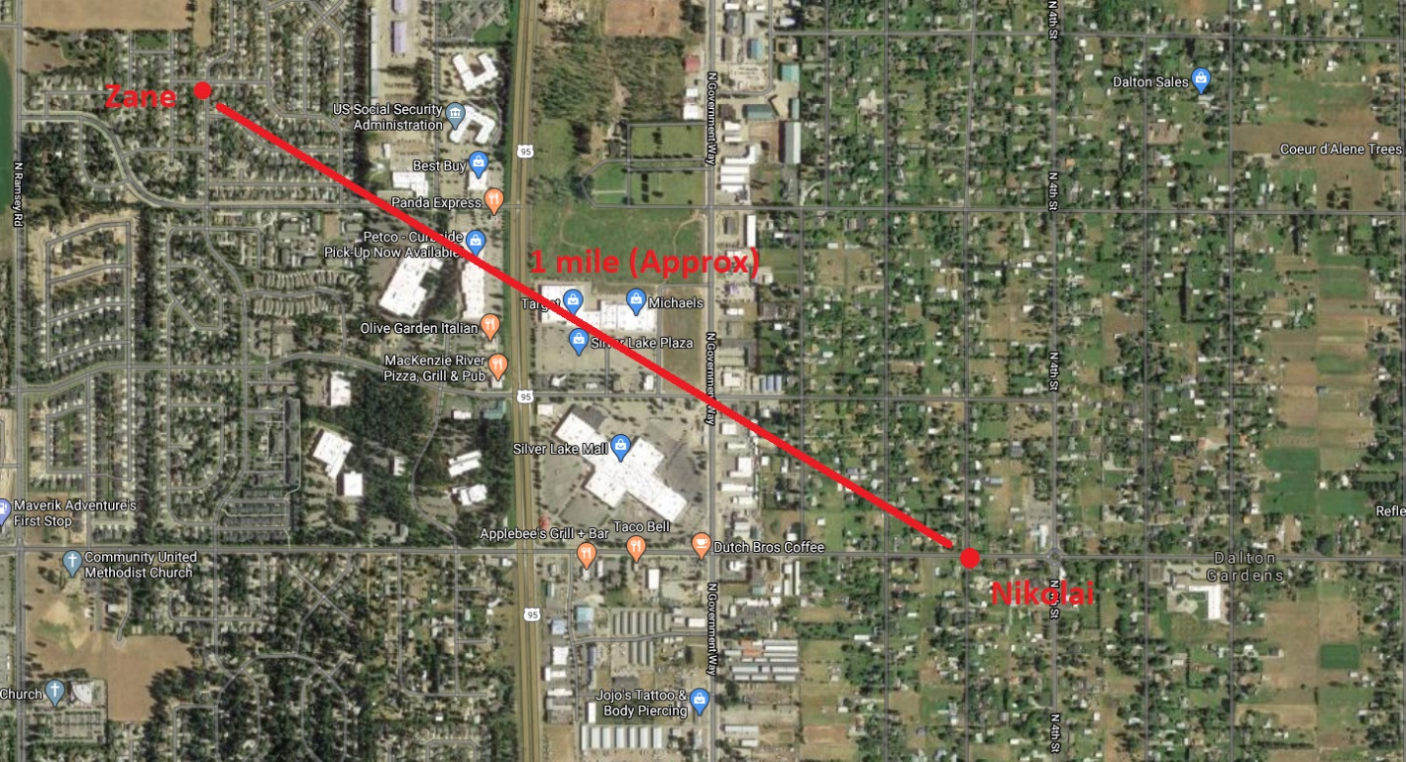

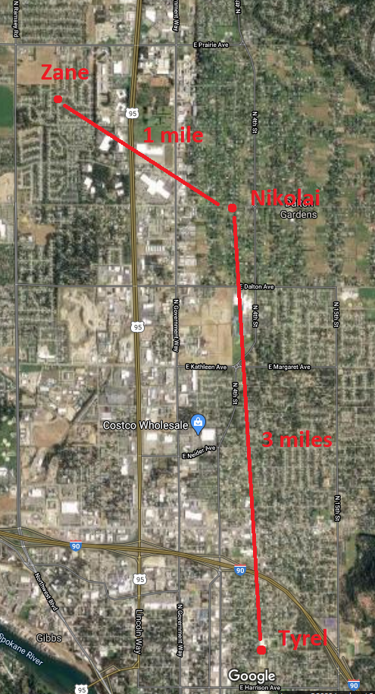

## System Architecture – 2+ pages

* Describe the conceptual design – justify continued development
* Describe the components and how they are integrated
* Highlight novel features – your “value added”
* Explain how does each major component satisfy requirements

## Design Evaluation – 2 pages

* Analyze DFMEA against project specifications (1-2 page Excel document included in Appendix)

(define scoring rubrics, assess design risks, and summarize key ideas for remediation)

* Explain product testing procedures
* Sustainability assessment
* Provide results from product performance testing

## Future Work – 1 page

* Make recommendations for sponsor in project adoption/implementation
* Identify features that didn’t find their way into the current design
* Estimate scope, duration, and cost of the required next steps

# Appendices

Supporting documents to long or detailed for main body

* Calculations, drawings
* Large tables, figures
* Computer programs
* Vendor data sheets
* 1-page Project Schedule in Excel (as originally planned at start of project)
* 1-page Project Schedule in Excel (as executed at end of project)
* DFMEA worksheet
* Overview of folder/file organization on shared drive